Avoid the Summer Slide

Summer slide is a term educators use for the lost academic progress between one grade level and another. With the emergency Distance Learning taking place this year, avoiding the Summer Slide is more important than ever before!
15 minutes a day keeps the Summer Slide away!

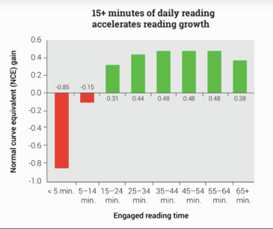

We are excited to announce the SSYR books for Middle School students. These are excellent books! You can check out the list here: https://www.floridamediaed.org/uploads/6/1/4/2/61420659/6-8_2020-21_ssyra_annotated_list_update.pdf

Need more books to read? We are encouraging the use of Bookshelf and pascolibraries.org to access books to read.

In Math, Zearn is a great resource to use. In fact, they anticipated our needs. Please check out https://about.zearn.org/learning-recovery . The videos, lessons and tasks are already created.

Summer is a wonderful time to experience life. All of the great adventures students participate in over summer will help them succeed academically too. Enjoy your summer!

